|  |
| --- |
| MATH 572 |
| Monkey Pox in the United States |
| Forecasting the effectiveness of educational intervention |

|  |
| --- |
| Hedieh Kalachahi (1467616), Saira Faiz (1775398), & Colby Jamieson (1714722)  4-11-2023 |

# Abstract

# Group Contributions

Hedieh Kalachahi (1467616): Initial project idea, sensitivity analysis research, final draft review, data fitting, power point editing, data preparing, and data source research.

Saira Faiz (1775398): First proposal draft, initial research, final draft review, model building, power point edits, data sourcing, and project planning.

Colby Jamieson (1714722): Proposal review and drafting, research objectives, initial model, draft report, model building, data fitting, data visualization, power point edits, and mathematical analysis.

# Introduction

The monkey pox virus was first discovered in humans in 1970 and has since become endemic in the Democratic Republic of Congo and has spread to other nearby countries in central and west Africa (Parker & Buller, 2013). The disease has garnered more attention recently due to numerous outbreaks around the world, especially in the United States. It is also notable for its similarity to smallpox, a disease that killed an estimated 300 million since the year 1900 (Mohr).

Monkey pox can be transmitted from contact between humans and infected rodents; however, the most recent outbreaks have occurred primarily due to close human-to-human contact. Transmission usually occurs from direct contact with infected rashes, scabs, and bodily fluid, but can also be transmitted by respiratory secretions. Typically, illness is moderate and resolves within 2-4 weeks, with those who are immune compromised having more severe symptoms, with the possibility of death (Peter, et al., 2022).

# Methods

To model the transmission of the virus and effectiveness of educational interventions, a compartmental mathematical model evaluated at different levels of intervention is developed. Once the model is calibrated, simulations will indicate how effective an educational programme would be in reducing the transmission of the virus.

Given different levels of educational effectiveness and coverage, the project objectives are to determine:

* Total population infected.
* How much of the population needs to be educated to reduce peak infections.

A simple SEIR model is used to first describe infection dynamics without intervention. With data from [insert data source] collected during the 2022 United States monkey pox outbreak, we fit our initial model to determine the infection rate parameter. We Parameters for recovery rate, and latent period is from prior research [insert citation] and assumed to be comparable across different outbreaks. The parameter for infection rate is considered more location specific and is therefore estimated using real data.

The initial model comprises of four compartments:

* Susceptible population
* Exposed hosts
* Infected hosts
* 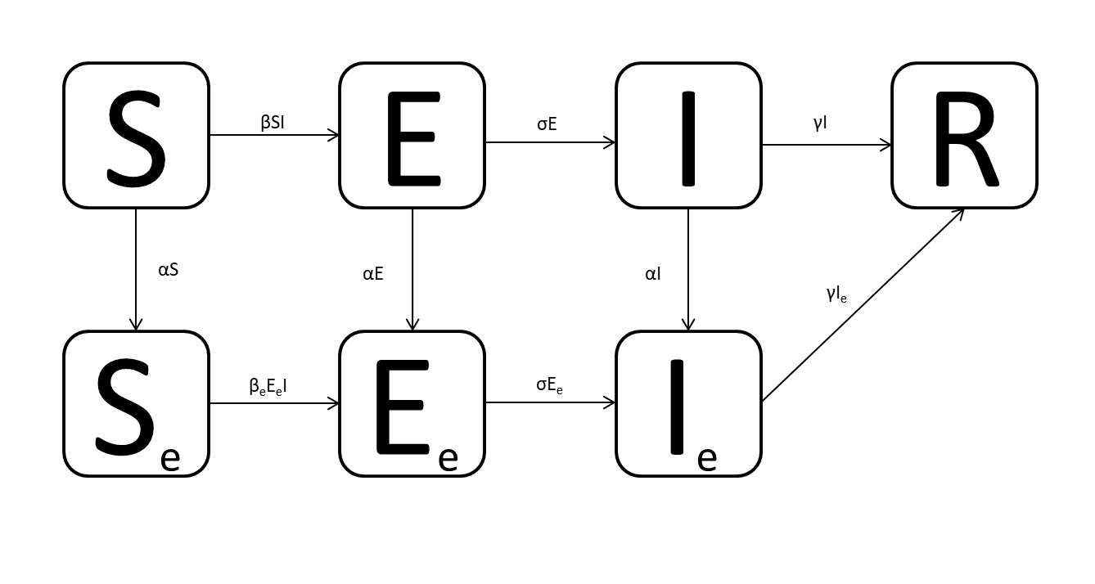Recovered

Figure 1 The original SEIR model is fit to data and estimates the infection rate parameter β.

Each compartment has parameters that control the rate of flow of hosts from one compartment to the others. Beta (β) is the rate at which the susceptible population is exposed to the virus and will eventually become infected. Sigma (σ) is the rate at which people in the exposed compartment become infected, and contagious. Lastly, gamma (γ) is the recovery rate.

|  |  |  |
| --- | --- | --- |
| Parameter | Symbol | Value |
| Infection rate | β | 0.0006 |
| Latency rate | σ | 0.83 |
| Recovery rate | γ | 0.20 |

Figure 2 Initial guesses of parameter values for SEIR model (Peter, et al., 2021).

Model parameters will be estimated by fitting the model to data from the 2022 outbreak in the United States (Centers for Disease Control and Prevention, 2023). The data contains 300 days of daily infections. Once the model is fit to the data using the least squares method, the model will be tuned to make predictions relevant to our analysis.

With model parameter calibrated, the initial model is expanded to include compartments for those within the population who receive infection prevention education. People in the susceptible, exposed, and infected compartments flow into the educated stream at a constant rate alpha (α), and are assumed to have a smaller infection rate and to not spread the disease when infected. The recovery rate and latency period are assumed to remain the same.



Figure 3 The modified model adds compartments for those who have received the educational intervention.

### System of Equations:

$$\frac{dS}{dt}= -αS-βSI$$

$$\frac{dS_{e}}{dt}= αS-β_{E}S_{E}I$$

$$\frac{dE}{dt}= βSI-αE-σE$$

$$\frac{dE_{e}}{dt}= β_{E}S_{E}I+αE-σE_{e}$$

$$\frac{dI}{dt}= σE-αI-γI$$

$$\frac{dI_{e}}{dt}= σE_{e}+αI-γI_{e}$$

$$\frac{dR}{dt}= γI+γI_{e}$$

### Variables and Parameters:

Population variables:

S – susceptible

Se – susceptible population that received educational intervention

E – exposed

Ee – exposed population that received educational intervention

I – infected

Ie – infected population that received educational intervention

Parameters:

β – infectious rate for susceptible population

βe – infectious rate for susceptible population that received educational intervention

σ – exposed to infected rate

γ – recovery rate

α – education rate

Alpha is considered a parameter that can be influenced by public policy; and therefore, is set to different levels and analyzed, to be interpreted as the coverage a particular intervention would have in the population. The infectious rate of the educated stream is also set to differing levels and interpreted as intervention efficacy. Efficacy ranges from 0% to 4%; therefore, we test interventions at selected levels in this interval.

|  |  |
| --- | --- |
| Intervention Type | Risk Reduction |
| Abstinence | 0% |
| Comprehensive | 4% |
| All types | 1% |

Figure 4 Estimated risk reduction by intervention type (Petrova & Garcia-Retamero, 2015).

To ensure that the model is comprehensive enough to be useful but simple enough to be computationally feasible and interpretable, a number of assumptions are made:

1. Horizontal transmission through direct contact with infected.
2. Homogeneous individual mixing.
3. Rate of transfer proportional to population size of compartment.
4. Infected individuals have latency period.
5. Total immunity acquired after infection.
6. No input or output of individuals through birth, migration, or death.
7. Educated infected individuals quarantine and do not infect others.
8. Education rate is constant for each compartment.
9. Recovery rate is constant for each infected compartment.
10. Individuals represented in data are considered not educated.
11. Effectiveness of educational interventions studied are comparable to proposed monkey pox intervention.
12. There is no vaccine.

The model is run on various levels of intervention coverage. The total infected is determined to be the number in the recovered compartment after the outbreak has run its course. This is our indication of intervention effectiveness by total number of people affected. The effect of peak infections will be assessed by comparing daily infection curves at different levels of education coverage. To determine the degree to which the intervention effectiveness and coverage affects infections, a sensitivity analysis is performed. With these results the objectives of this study will be reached.

# Results

Model fitting was successful and the optimized parameter values were found. When comparing optimal values to initial guesses, the infection and latency rates decreased while the recovery rate decreased. All parameters remained within an appropriate bound.

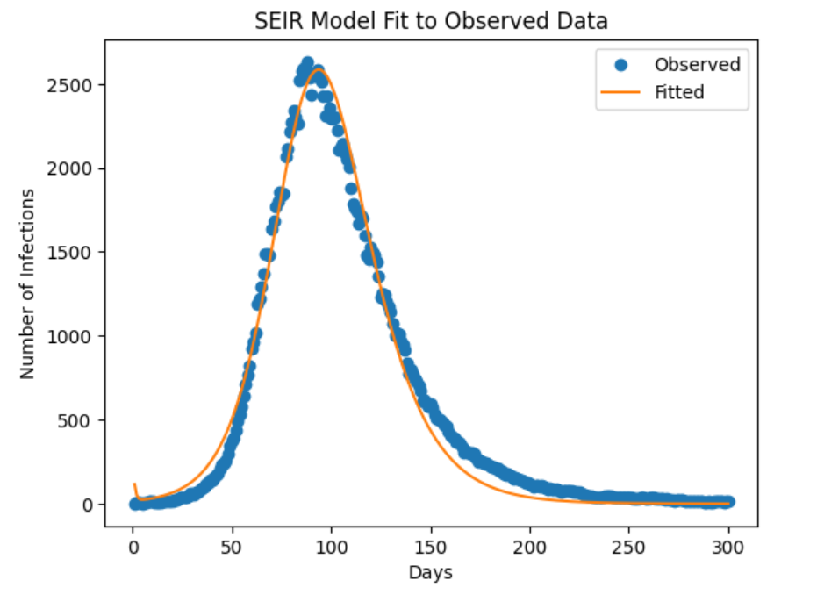

Figure 5 The model is fit to real infection data to find optimal parameter values.

|  |  |
| --- | --- |
| Parameter | Optimized value |
| Infected (β) | 0.00000841 |
| Latency rate (σ) | 0.095 |
| Recovery rate (γ) | 0.891 |

Figure 6 Optimized parameter values.

The simulation results when varying education level indicates that education rates of 0.001 to 0.004 could be effective in significantly reducing peak infections, with the infectious curve nearly linear at the higher education level.



Figure 7 Education significantly decreases peak infections.

Education also had a notable effect on total infected, reducing total infections from 70,424 with no intervention, to 1,551 with an education rate of 0.004, a 98 per cent decrease from the baseline.

Figure 8 Education significantly decreases total infected.

Figure 9 An education rate of 0.4% per day decreases total infections by 98 per cent.

# References

Centers for Disease Control and Prevention. (2023, March 29). *U.S. Mpox Case Trends Reported to CDC*. Retrieved from Centers for Disease Control and Prevention: https://www.cdc.gov/poxvirus/mpox/response/2022/mpx-trends.html

Mohr, J. (n.d.). *Smallpox*. Retrieved from American Museum of Natural History: https://www.amnh.org/explore/science-topics/disease-eradication/countdown-to-zero/smallpox#:~:text=One%20of%20history's%20deadliest%20diseases,the%20first%20disease%20ever%20eradicated.

Parker, S., & Buller, R. M. (2013). A review of experimental and natural infections of animals with monkeypox virus between 1958 and 2012. *Future Virol*, 129-157.

Peter, O. J., Abidemi, A., Ojo, M. M., & Ayoola, T. A. (2023). Mathematical model and analysis of monkeypox with control strategies. *The European Physical Journal Plus*.

Peter, O. J., Kumar, S., Kumari, N., Oguntolu, F. A., Oshinubi, K., & Musa, R. (2021). Transmission dynamics of Monkeypox virus: a mathematical modelling approach. *Nature Public Health Emergency Collection*, 3423–3434.

Peter, O. J., Oguntolu, F. A., Ojo, M. M., Oyeniyi, A. O., Jan, R., & Khan, I. (2022). Historically, outbreaks of monkeypox have been linked to animal-to-human transmission, where wild animals like African rats and monkeys transmit the virus to people which could occur as a result of bites or scratches the processing of bush meat, direct co. *Physica Scripta*.

# Briefing Note: Government

**Title:** Advice to Minister of the Department of Health on monkey pox transmission and educational prevention.

**Issue**

* The Minister has requested a summary of report entitled “Monkey Pox Transmission and Educational Intervention” (Attachment 1).

**Purpose**

* To provide information to the Minister on the transmission dynamics of the monkey pox virus and potential educational intervention effectiveness.

**Background**

* In December 2022, the Minister of the Department of Health granted approval for one departmental data analyst to attend MATH 572 Mathematical Modelling for Industry, Government, and Sciences.
* 2022 a monkey pox outbreak infected 30,286 and killed 38 in the United States.

**Analysis**

* Educational intervention that reaches 0.1 to 0.4 percent of susceptible population estimated to reduce total infections by 60 to 98 per cent, respectively.

**Stakeholder Reaction**

* Preventative educational program administrators may request more funding.

**Communications/Key Messages**

* Based on mathematical infectious disease modelling, preventative education may decrease the total number of monkey pox infections 60 to 98 per cent in the event of an outbreak.

**Financial Implications**

* No financial implications.

**Attachments**

1. Report on monkey pox transmission and educational intervention effectiveness.

Prepared by: Colby Jamieson

# Appendix A: Project Proposal

|  |
| --- |
| MATH 572 |
| Monkey Pox in the United States |
| Forecasting the effectiveness of educational intervention |

|  |
| --- |
| Hedieh Kalachahi (1467616), Saira Faiz (1775398), & Colby Jamieson (1714722)  4-11-2023 |

# Description

To model the transmission and prevention of the monkeypox virus, we propose a compartmental mathematical model evaluated at different levels of intervention. The project will aim to construct a model specific to a local outbreak of monkeypox in Alberta. The intended audience are government officials wanting a description of the threat the virus poses to Albertans and if a public education intervention might be effective in reducing transmission.

# Background

The monkeypox virus was first discovered in humans in 1970 and has since become endemic in the Democratic Republic of Congo and has spread to other nearby countries in central and west Africa (Parker & Buller, 2013).The disease has garnered more attention recently due to numerous outbreaks around the world and its similarity to smallpox, a disease that killed an estimated 300 million since the year 1900 (Mohr).

Monkeypox can be transmitted from contact between humans and infected rodents; however, the most recent outbreaks have occurred primarily due to human-to-human contact. Transmission usually occurs from direct contact with infected rashes, scabs, and bodily fluid, but can also be transmitted by respiratory secretions. Once transmitted, infection results in flu-like symptoms and the characteristic rash, turning into painful blisters. Typically, illness is moderate and resolves within 2-4 weeks, with those who are immune compromised having more severe symptoms, with the possibility of death (Peter, et al., 2022).

There is currently no vaccine or treatment specific to monkeypox. There are however vaccines and treatments developed for smallpox that are effective (Peter, et al., 2022).

# Research Objectives

The objective of this research is to understand the transmission dynamics of local outbreaks of monkeypox and to investigate the effect of public education about the virus on specific disease attributes, such as:

* Peak infections,
* final size, and
* endemic & disease-free equilibria

The research will be conducted for the purposes of public policy making and would include answers to questions such as:

* How many infections could we expect at one time during the peak of the outbreak?
* Will the pandemic end or become endemic?
* How many Albertans could be affected by the disease before the pandemic ends?
* Will public education have a significant effect on the impact the disease outbreak has on Albertans?

# Method

To achieve the research objectives set out in this proposal, a compartmental model of monkeypox is proposed. The model will be constructed using Matlab and results will be presented in a report and presentation aimed at public health policy decision-makers. The research questions will be answered by mathematical analysis of model results. This analysis will include peak infections, final size, and equilibria that will be evaluated at various levels of intervention and input levels.

## Preliminary Model

The preliminary model proposed is a simplified version of previous monkey pox modelling (Peter, et al., 2021). The purpose of the proposed model is to describe local outbreak dynamics in Alberta; therefore, compartment for rodent transmission is removed, as it is assumed that a local spread would likely be human to human.

SE

S

I

R

βIS

βEISE

αS

γI

To study the dynamic effects of a realistic intervention during a local outbreak, a compartment for educated susceptible population is added. Once the simplified model is run and calibrated, other compartments may be added or removed; such as age groups, birth and death rates, high risk susceptible population, quarantined population, or infected population yet to be contagious.

### System of Equations:

$\frac{dS}{dt}= -βSI$

$\frac{dS_{E}}{dt}= αS-β_{E}IS_{E}$

$$\frac{dI}{dt}= I\left(βS+β_{E}S_{E}\right)-γI$$

$$\frac{dR}{dt}= γI$$

### Variables and Parameters:

S – Number of uneducated susceptible population SE – Number of educated susceptible population

β – infectious rate for uneducated population βE – infectious rate for educated population

I – number of infected population R – number of recovered population

α – education rate γ – recovery rate

## Sensitivity Analysis

A global sensitivity analysis will be performed to discern the impact on outputs relating to uncertainties of model inputs.

## Data Sources

To date, no suitable data sources for model fitting have been found.

## Mathematical Analysis

Mathematical analysis will include a final size estimate, finding the total people infected from the number of initial susceptible minus the susceptible at the end of the pandemic ( S0 - S∞). This will be determined mostly by the basic reproduction number.

Peak infections will be analyzed given different levels of intervention, and inputs.

Local stability analysis will be performed to determine which equilibrium points are stable or unstable. This will include a phase-line analysis, bi-furcation diagram, and the basic reproduction number level that results in either a disease-free or endemic equilibrium.

# Group Contributions

Hedieh Kalachahi (1467616): Initial project idea, sensitivity analysis research, final draft review, and data source research.

Saira Faiz (1775398): First proposal draft, initial research, final draft review, and project planning

Colby Jamieson (1714722): Proposal review and drafting, research objectives, initial model, and mathematical analysis.